BePCIS invites you to a course on

Dispersions and Emulsions:
Formation, Stabilization and Characterization

Date: April 10th - 12th, 2018

Time: 8:30 am to 5:30 pm
(9:30 am on Tuesday; 4:00 pm on Thursday)

Venue: Het Pand, Priorzaal
Onderbergen 1
9000 Gent
https://www.ugent.be/het-pand/nl/contact

Residential Seminar: We strongly suggest staying in Gent during the 3 days as this will facilitate networking with your fellow trainees and with the lecturers. See the attached document for proposed hotels

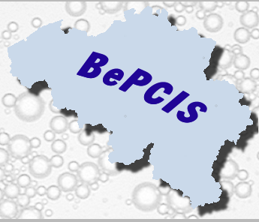
Social Program: A social program will be arranged on the second day of the course (see program).

Course Fee: The course fee amounts to € 900; there is a reduced early bird fee of € 800 when registering prior to March 1.
We offer a reduced registration fee for PhD students. (€ 350 – limited slots available; contact Saskia.Vanderlooven@UGent.be).

Registration: Please confirm your attendance to Saskia.Vanderlooven@UGent.be and transfer the course fee to our bank account
979-9983500-71 (IBAN: BE49 9799 9835 0071; SWIFT: ARSPBE22).
The registration fee includes all course material, lunches, refreshments and participation to the social program.

Program

Dispersions and Emulsions:
Formation, Stabilization and Characterization

Day 1 Tuesday, April 10th, 2018
Theory of Colloid Stability.
Steric, Electrosteric Stabilisation and Flocculation by Polymers and Polyelectrolytes.
Electrokinetics and Zeta-potential.

Applications - invited speakers

Day 2 Wednesday, April 11th, 2018
Birth and life of dispersions and emulsions. Choice of dispersant, surfactant, emulsifier agent. Technology of dispersion/emulsion preparation.

Lab demos and Particle sizing instrumentation

Social Program & Course dinner

Day 3 Thursday, April 12th, 2018
Concentrated Dispersions. Surfactant self-association behaviour. Rheology fundamentals. Rheology of concentrated dispersions. Gravitational effects.

Applications - invited speakers

A more detailed course program is also available on our website www.bepcis.org

